Type of the Paper (Article, Review, Communication, etc.)
Title
Academic Editor: Firstname Lastname
Received: date
Revised: date
Accepted: date
Published: date
Citation: To be added by editorial staff during production.
Copyright: © 2025 by the authors. This manuscript is submitted for possible open access publication under the terms of the Creative Commons Attribution (CC BY) License (https://creativecommons.org/licenses/by/4.0/), which permits unrestricted use, distribution, and reproduction in any medium, provided the original work is properly cited.
Firstname Lastname ¹, Firstname Lastname ² and Firstname Lastname ^{2,}*
¹ Affiliation 1; e-mail@e-mail.com
² Affiliation 2; e-mail@e-mail.com
* Correspondence: e-mail@e-mail.com; Tel.: (optional; include country code; Only one author should be designated as corresponding author)
Abstract
The abstract should be a single paragraph of no more than 200 words. It must provide a clear and concise summary of the study without references or unexplained abbreviations. Authors are encouraged to structure the abstract in a logical flow that covers the following elements: Background (context of the problem and purpose of the study), Methods (key approaches and data used), Results (main findings), and Conclusion (significance of the outcomes). The abstract should accurately represent the content of the article and avoid including results or claims that are not substantiated in the main text.
Keywords: Provide three to ten relevant keywords separated by semicolons (e.g., climate change; vegetation stress; remote sensing).

1. Introduction
The introduction should provide a clear background to the study, situating the research problem within a broader environmental and scientific context. Authors are expected to highlight the importance of the study, define its objectives, and state its contribution to advancing knowledge in the field. A critical review of relevant literature should be included to establish the current state of research, identify gaps, and justify the need for the study. Where appropriate, authors should reference conflicting findings or diverging perspectives in previous studies.
The section should conclude with a precise statement of the research aims or hypotheses. To ensure accessibility, the introduction should be written in a manner that is understandable to readers from related disciplines. All references must follow APA style guidelines, with in-text citations formatted as author–date (e.g., Smith, 2020; Adeyemi & Musa, 2021), and listed in full in the reference list at the end of the manuscript.
.

2. Materials and Methods
This section should provide sufficient detail to allow replication of the study. Authors must describe the study area, datasets, instruments, materials, and analytical procedures in a clear and systematic manner. Methods should be presented in chronological order or grouped logically by type of analysis.
For established methods, provide appropriate references (e.g., Johnson, 2019). New or modified methods should be described in detail to ensure reproducibility. Where relevant, authors should specify the software, programming languages, or statistical packages used, including version numbers (e.g., R 4.3.2; ArcGIS Pro 3.2).
If the study involves humans, animals, or sensitive data, ethical approval details must be included, citing the approving authority and reference number. For ecological or environmental studies requiring permits, state the issuing authority.
Authors should also disclose any restrictions on data or material availability. Large datasets deposited in public repositories must include the repository name and accession numbers. If generative artificial intelligence (e.g., ChatGPT, Stable Diffusion) was used beyond grammar or formatting edits, its role must be explicitly acknowledged in this section.
All procedures should be written in past tense, precise, and objective to maintain scientific clarity.

3. Results
This section may be divided by subheadings. It should provide a concise and precise description of the experimental results, their interpretation, as well as the experimental conclusions that can be drawn.

3.1. Subsection

3.1.1. Subsubsection

3.2. Figures, Tables and Schemes
All figures and tables must be cited in the main text in sequential order (e.g., Figure 1, Table 1). Each figure or table should include a clear, descriptive caption placed directly below (for figures) or above (for tables). Captions should explain the content fully without requiring reference to the main text.
If a figure contains multiple panels, each should be labeled (e.g., a, b, c) and described clearly in the caption (e.g., “(a) Map of study area; (b) Seasonal variation of NDVI”). Figures should be inserted in the main text close to their first citation to maintain readability.
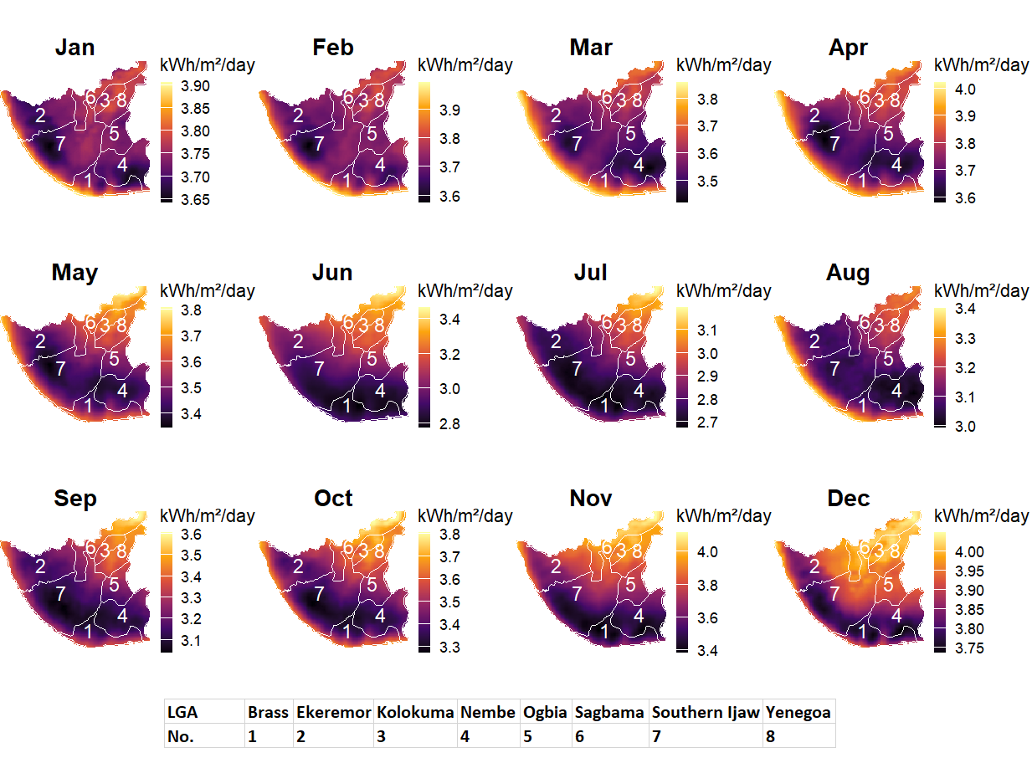
Figure 1. Monthly variation of solar radiation (kWh/m²/day) across the eight Local Government Areas (LGAs) of Bayelsa State, Nigeria (Brass, Ekeremor, Kolokuma, Nembe, Ogbia, Sagbama, Southern Ijaw, and Yenegoa). Each map panel represents the spatial distribution for a given month, illustrating seasonal patterns and local differences in solar energy availability.
Table 1. This is a table. Tables should be placed in the main text near to the first time they are cited.
Title 1 | Title 2 | Title 3
entry 1 | data | data
entry 2 | data | data ¹
¹ Tables may have a footer.

3.3. Formatting of Mathematical Components
Equations should be presented clearly, numbered consecutively, and cited in the text using their assigned number (e.g., Equation 1). Equations should be punctuated as part of the running text rather than treated as standalone paragraphs.
Example:
$$a=7$$ | (1)
The text following an equation should continue on the same line or in the same paragraph.
This is example 2 of an equation:
$$a=b+c+d………..+z$$ | (2)

4. Discussion
This section should interpret the results in relation to the study objectives and existing literature. Authors are expected to explain how the findings support, contrast with, or extend previous research and to address the implications of the results within a broader environmental and scientific context. Limitations of the study should be acknowledged where relevant. Future research directions may also be suggested to guide subsequent studies.

5. Conclusions
The conclusion should provide a clear and concise summary of the main findings, emphasizing their significance and contribution to the field. Authors should avoid repeating detailed results and instead highlight the key outcomes, practical implications, and relevance of the study. Where appropriate, recommendations for policy, practice, or further research may be included.

6. Patents
If the research has resulted in a patent application or granted patent, the details should be provided in this section. Please include the patent title, applicant(s), patent number (if available), and relevant filing or publication dates. If no patents are associated with the work, this section may be omitted.
Supplementary Materials: Authors may provide supplementary files that support the findings of the manuscript but are not essential to its main text. These may include additional figures, tables, datasets, videos, or protocols. Supplementary files should be clearly labeled (e.g., Figure S1, Table S1, Dataset S1, Video S1) and cited appropriately in the main text.
Examples of acceptable statements include:
- “The following supporting information can be downloaded at: [URL or DOI], Figure S1: [title]; Table S1: [title]; Dataset S1: [title].”
- “Supplementary materials are available from the corresponding author upon request.”
All supplementary content must meet the same ethical and quality standards as the main article.
Author Contributions: For manuscripts with multiple authors, individual contributions must be clearly stated using the CRediT (Contributor Roles Taxonomy). Only those who have made substantial contributions to the research should be listed as authors.
An example format is as follows:
Conceptualization, A.A. and B.B.; Methodology, A.A.; Software, C.C.; Validation, A.A., B.B., and C.C.; Formal Analysis, A.A.; Investigation, A.A.; Resources, B.B.; Data Curation, C.C.; Writing—Original Draft, A.A.; Writing—Review & Editing, B.B. and C.C.; Visualization, A.A.; Supervision, B.B.; Project Administration, B.B.; Funding Acquisition, C.C.
All authors must confirm that they have read and approved the final version of the manuscript.
Funding: Authors must provide a clear statement regarding the source of financial support for their research. If the study received funding, specify the name of the funding agency, the grant number, and any relevant project information. Ensure that the official spelling of funding agency names is used.
If the article processing charge (APC) was supported by an institution or funder, this should also be acknowledged.
Examples of acceptable statements include:
- “This research received no external funding.”
- “This research was funded by [Name of Funder], grant number [XXX].”
- “The article processing charge (APC) was funded by [Name of Institution or Funder].”
.
Data Availability Statement: Authors are strongly encouraged to make research data openly available to ensure transparency and reproducibility. This section should clearly indicate where the data supporting the findings of the study can be accessed. Provide repository names, accession numbers, or direct links to publicly archived datasets where applicable.
If no new data were created, or if data cannot be shared due to privacy, confidentiality, or ethical restrictions, authors must still include a statement explaining the reason.
Examples of acceptable statements include:
- “The data that support the findings of this study are openly available in [repository name] at [DOI or URL].”
- “The data presented in this study are available on request from the corresponding author.”
- “No new data were created or analyzed in this study. Data sharing is not applicable.”
- “Restrictions apply to the availability of these data due to [reason]. Data are available from the corresponding author with permission.”
Acknowledgments: In this section, authors may recognize any form of support that is not included under Author Contributions or Funding. This may include:
- Administrative or technical assistance.
- Provision of materials, equipment, or facilities.
- Contributions in kind (e.g., field access, laboratory space, or data sharing).
Where generative artificial intelligence (GenAI) tools have been used for purposes beyond minor editing (such as generating text, data, figures, or assisting in study design, analysis, or interpretation), authors must provide a disclosure statement. For example:
“During the preparation of this manuscript, the author(s) used [tool name, version] for [specific purpose]. The authors reviewed and edited the output and take full responsibility for the content of this publication.”

Conflicts of Interest: Authors must clearly declare any potential conflicts of interest that could be perceived as influencing the presentation or interpretation of the research. This includes personal, financial, professional, or institutional relationships that may affect objectivity.
If the research received funding, the role of the funder(s) in the study—such as in its design, data collection, analysis, manuscript preparation, or publication decision—must be explicitly stated.
If no conflicts exist, authors should include the statement:
“The authors declare no conflicts of interest.”
If funders had no role, authors should include the statement:
“The funders had no role in the design of the study; in the collection, analysis, or interpretation of data; in the writing of the manuscript; or in the decision to publish the results.”

Abbreviations
The following abbreviations are used in this manuscript:
HJE | Hensard Journal of Environment
GEE | Google Earth Engine
GIS | Geographic Information System
NDVI | Normalized Difference Vegetation Index
LULC | Land Use/Land Cover
HJE | Hensard Journal of Environment
GEE | Google Earth Engine

Appendix
Appendices are optional and should be used to provide supporting details that would otherwise interrupt the flow of the main text. Examples include:
- Additional descriptions of experimental methods.
- Figures showing replicates or supplementary data.
- Extended mathematical proofs or derivations.
If included, appendices must be cited in the main text. Each appendix should be labeled sequentially (Appendix A, Appendix B, etc.). Figures, tables, and equations within appendices should also be labeled accordingly, for example: Figure A1, Table A1, or Equation A1.
Table A1. This is a table caption.
Title 1 | Title 2 | Title 3
entry 1 | data | data
entry 2 | data | data

References
All references must follow APA 7th edition style. In-text citations should use the author–date format, for example: (Smith, 2020), (Adeyemi & Musa, 2021), or (Okafor, 2018; Johnson, 2019). When directly quoting, include page numbers (e.g., Brown, 2022, p. 15). Multiple citations should be listed chronologically and separated by semicolons.
Authors are strongly encouraged to use a reference management tool such as EndNote, Zotero, or Mendeley to ensure accuracy, consistency, and to avoid duplication. Where available, the DOI (digital object identifier) must be included. References cited in Supplementary Materials should also be included in the main reference list.
Examples of reference formats:
- Journal article
Adeyemi, T., & Musa, K. (2021). Climate variability and vegetation dynamics in semi-arid Nigeria. Journal of Environmental Research, 45(3), 210–225. https://doi.org/10.1016/j.jer.2021.03.005
- Book
Smith, J. A. (2019). Environmental change in West Africa (3rd ed.). Routledge.
- Book chapter
Okafor, L. C., & Bello, M. (2018). Remote sensing applications for ecological monitoring. In P. Daniels & R. Thomas (Eds.), Advances in geospatial technologies (pp. 154–176). Springer.
- Conference paper
Yusuf, A., & Ibrahim, H. (2020, July 15–17). Land use transitions in northern Nigeria. In Proceedings of the International Conference on Environmental Sustainability (pp. 45–52). Abuja, Nigeria.
- Thesis/Dissertation
Ibrahim, Z. (2022). Urban heat islands and land surface temperature patterns in Lagos (Doctoral dissertation, University of Lagos).
- Website
United Nations Environment Programme. (2023). Climate action and resilience. https://www.unep.org/climate
Disclaimer/Publisher’s Note: The views, opinions, and data expressed in articles published in the Hensard Journal of Environment are solely those of the author(s) and contributor(s). They do not necessarily reflect the position of the Journal, the editors, or Hensard University. The Journal and its editorial team disclaim responsibility for any harm, injury, or loss that may result from the use of ideas, methods, instructions, or products discussed in the published content..

